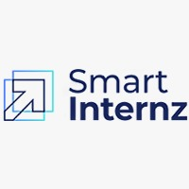



Digital worker for student grading using Databases

By

Pratyus Basuli 20BCR7076

Project ID: [SI-GuidedProject-51908-1653729805](https://github.com/smartinternz02/SI-GuidedProject-51908-1653729805)

# Content

1. **Introduction**
   1. Overview
   2. Purpose
2. **Project flow**
   1. Prerequisites
   2. Creating database
   3. Importing required VBO's
   4. Creating Blue prism Process Model
   5. Running the flow to get the desired results
3. **Result**
   1. Observations
   2. Applications
   3. Future Scope

# Introduction

## Overview

In this modern day and age there are still many fields of area where a substantial amount of the tasks are performed manually on paper. With the fast pace in today's work, such activities often lag in this Digital era and because of the complex nature of these tasks, the only way to maintain with the pace is to employ more workers, increasing the costs and workload on the employees. This is besides the obvious downside of manual processes being human and calculation errors are a common occurrence.

Such tasks can be totally digitized and thus reducing costs and removing human errors using *Robotic Process Automation(RPA).*

## Purpose

For our project we take the case of Student Grading using Databases (DB), a common back office task still heavily paper based, repetitive and time-consuming in many of the Academic departments of various Schools and Colleges. Thus RPA here stands as an ideal fit to automate this process so as to Students get a faster report cards and the Departments can concentrate on other important student centric activities and tasks.

Here we develop a bot that retries the data that is marks of the student from the database and allocates the grades to the students based on the marks secured. Once the grades are assigned to the student the grades are stored back in the database. This process will help the exam cell authorities to complete their task in no time and without any errors.

# Project Flow

## Prerequisite

For this Project one must require the following concepts and Software

* Knowledge of programming language, network structures, Should know how to perform administrator activities on windows server. Understanding of Installation models and design of infrastructure. Able to detect repeating tasks and automate them
* Knowledge on Microsoft SQL Management Studio
* Knowledge on Databases, Tables, and should be able to write simple SQL queries.
* Blue Prism Software
* Microsoft SQL Management Studio and associated soft wares in the development kit

* Installation and Setup Guide for Blue Prism: https://www.youtube.com/watch?v=SKMXYqmvAZI
* Microsoft SQL Management Studio: https://aka.ms/ssmsfullsetup (Software download link)

## Creating Database

In the Microsoft SQL Management Studio connect to the server and database connection. In our case, we use our local computer as our database server. Thus we connect to it and create a new Database in the Database Folder named as Student Database.

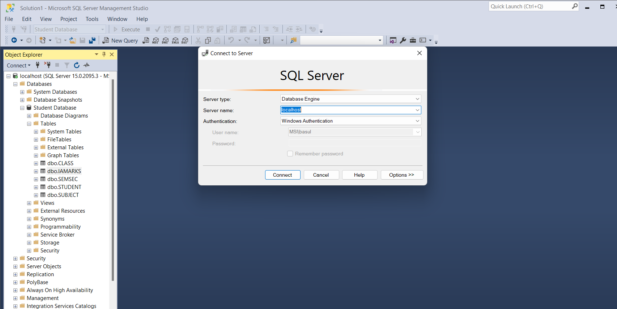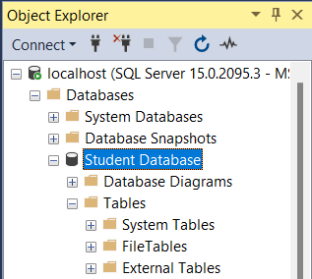

### Tables and entries:

Next we enter 5 tables by right clicking on the Database and choosing New Tables option

* Sem Section table
* Student
* Class
* Subject
* IA Marks

We input entries for first four tables as per our needs. The description of the tables are shown in this dependency diagram

## Importing VBO's

Now we start our implementation on Blue Prism, we import the VBO's from our Blue Prism Automate folder using the Import options under file Section.The two VBO's we need for our Project are:

* Data-SQL Server
* Email-POP3/SMTP

## Creating BluePrism Project Model

We create a new process "Student Database Grading" and open the Process studio

### 1. Server connection

We make the Action stages for server Connection by adding our Server name and Database

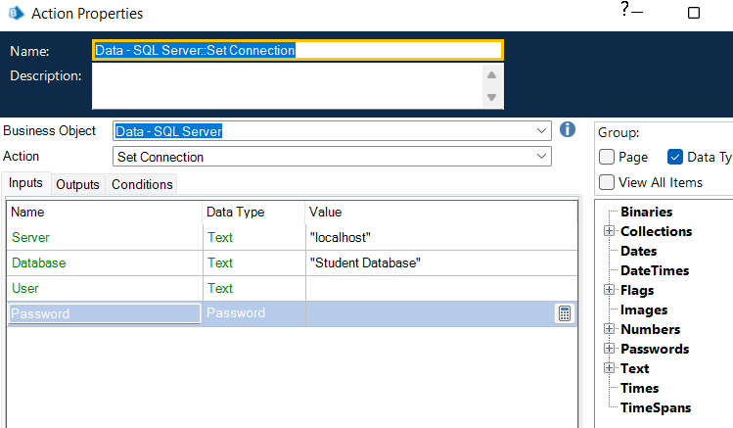

### 2. Create collection

Create a collection of the IA marks named IA marks with he matching columns to the actual table

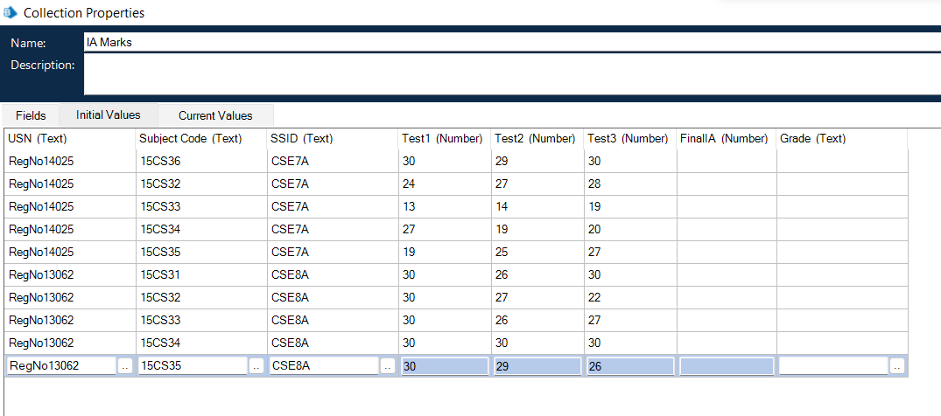and enter data accordingly.

### 3.Calculate the grades:

Create a loop stage to loop over IA Marks collection and put a calculation stage over it to calculate the average of three marks. This average is then run through a choice stage to allocate the grades with respect to each average.

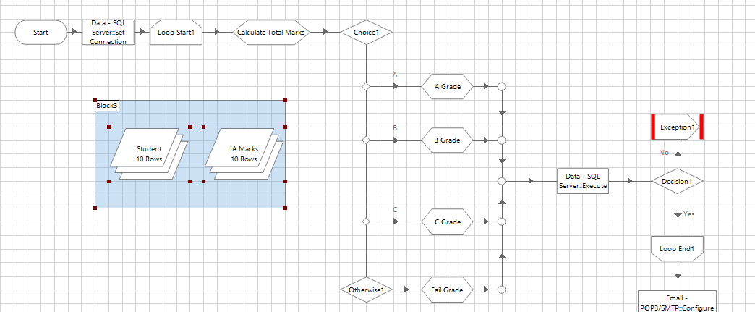

We also add SQL execute command before loop end which saves all the Grades with the average to the Database using the SQL-Server Business object action.

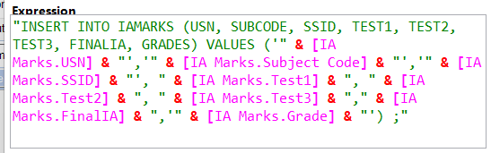

We added the needed exception stage in case or error in SQL execute stage and needed message to with it.

### 4. Sending the report through mail

We add two data items to store the mail and Password for our Gmail to send from the reports.In the next step we configure our Email VBO and make our personalized message for the student to send through email in the Message Stage.

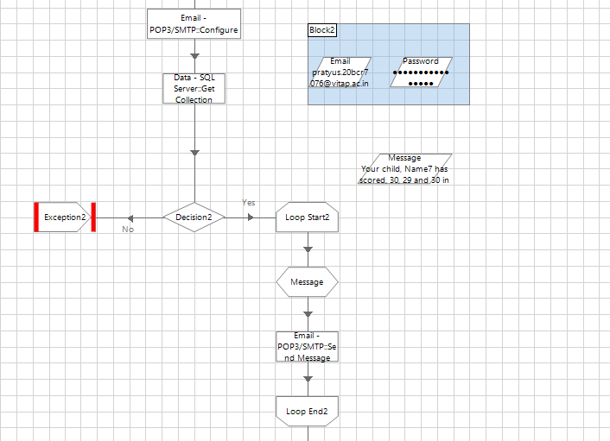

For the Personalized message we retrieve data back from all three tables and save it to the Student Collection and write the following message in the message stage

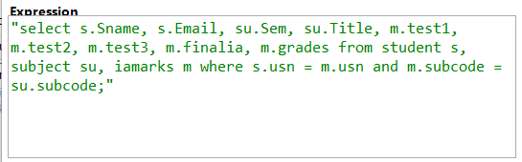

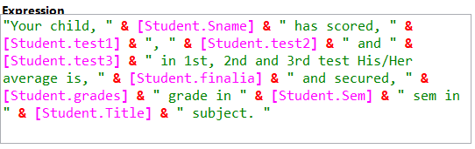

We send this message through the email Send Action and enter the message and Subject in the email. This stage gets looped over Student Collection thus is repeated for every student who has been graded from IA marks collection

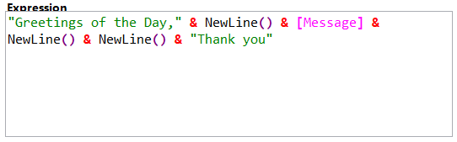

## Running the Process

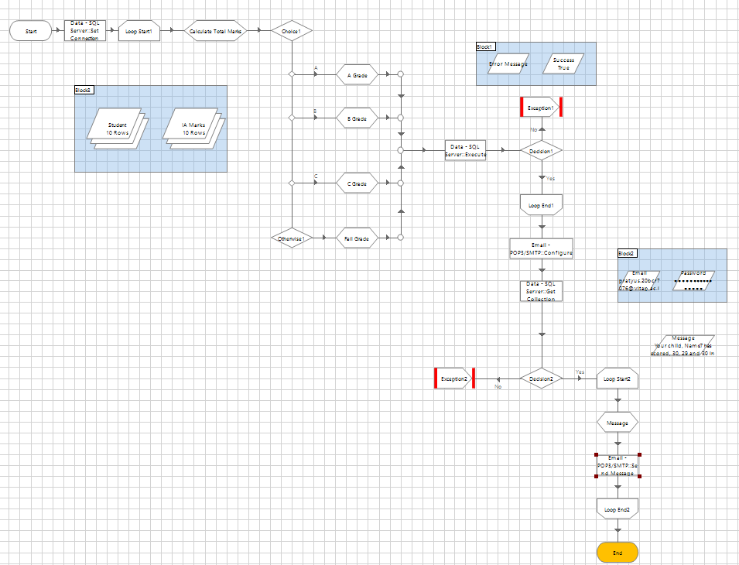

We wait for the desired results. We get these mails in our Gmail

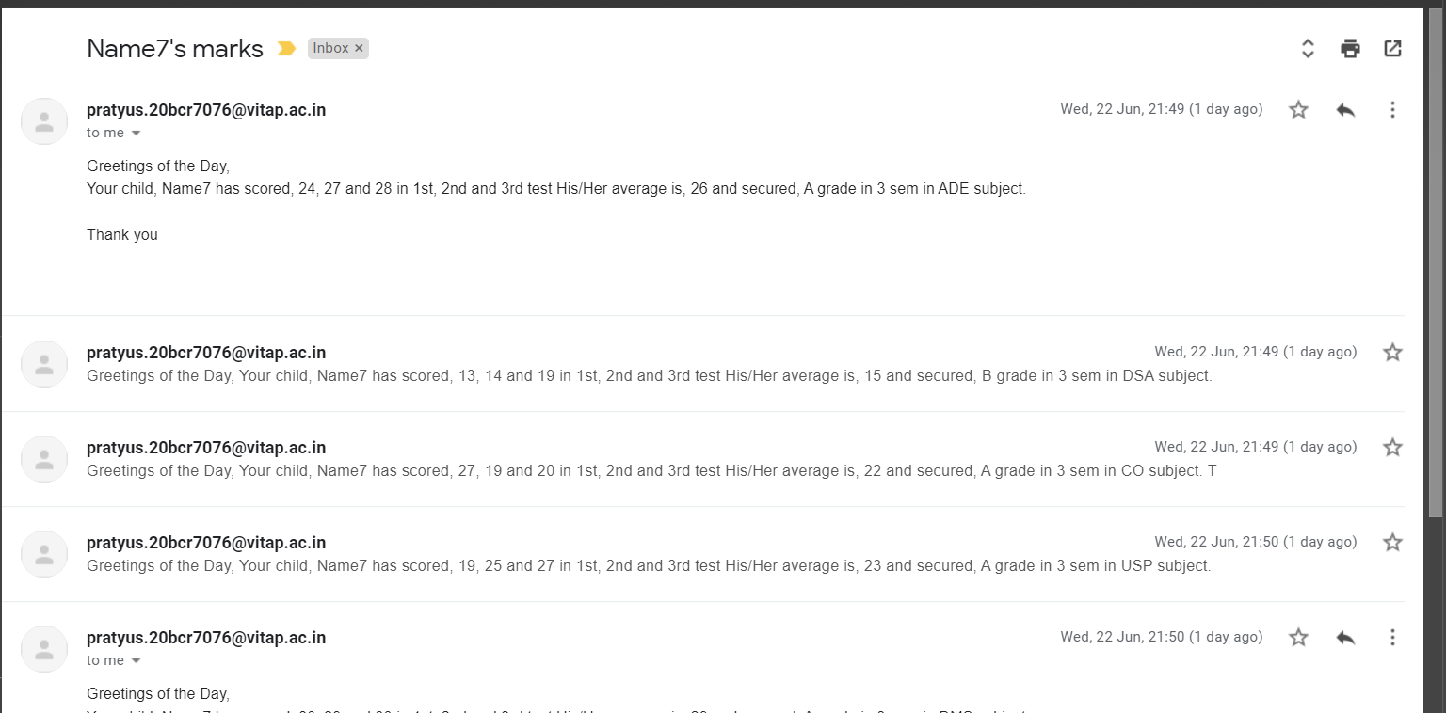

Thus our Bot runs successfully. For this stage we have used the same mails to check the mails but in real life applications we will use the actual student mail to send data.

# Result

## Observations

We see that our bot performed through a bulk data within minutes and sent the report to students as soon as the Grades were calculated thus there was not administrative delay's or paperwork in middle unlike real world that we usually get to see and thus creating an efficient system for the administrative process not just for Student Grading but keeping class schedules and keeping attendance and creation of report cards can be automated and the teachers and administrative staff left with much time to utilize to create student centric tasks and is beneficial for the students too as they get a better clarity when they get the grades near completion of exams and thus can perform better and improve their academic performance in the future semesters. Thus benefiting all round from students, teachers, cost and saving paper and time. This all is made possible due to RPA.

## Applications

RPA can similarly make many repetitive, manual and bulk work automated saving time and costs to company of all scale. Bots in Blue Prism are known as Digital Workers and they can be scheduled and deployed over many systems to automate the process. Digital workers can also be scheduled to work any specific day and time. From automating Banking sector, to appointments of slots to Doctors and Patients in Medical fields and making the Telecom industry by automating many tasks overlaying many different applications and platforms to humongous consumer data. RPA has many such applications in the real world especially for enterprise transitioning from paper to digital RPA is the the perfect fit. RPA also has use in Call center and Citrix applications making callers job easier to input the data coming at fast pace without affecting the work flow. It is also used in Finance and Accounting and Human Resources departments, Insurance,Data Scraping, Payroll automation the applications are countless.

## Future Scope

RPA if used wisely can be used to make efficient workflows and save time and costs for companies and is beneficial. The addition of AI/ML or CV or X technology to these bots make Intelligent Automations which transcend the boundary to manual workflows and can be used to automate any tasks possible. Thus many possibilities lie ahead and can be used to achieve various targets.